1) Write a java code with the class named ‘acad’ and a method ‘main’. Hard Code the program

with two integers and print the sum of those two.

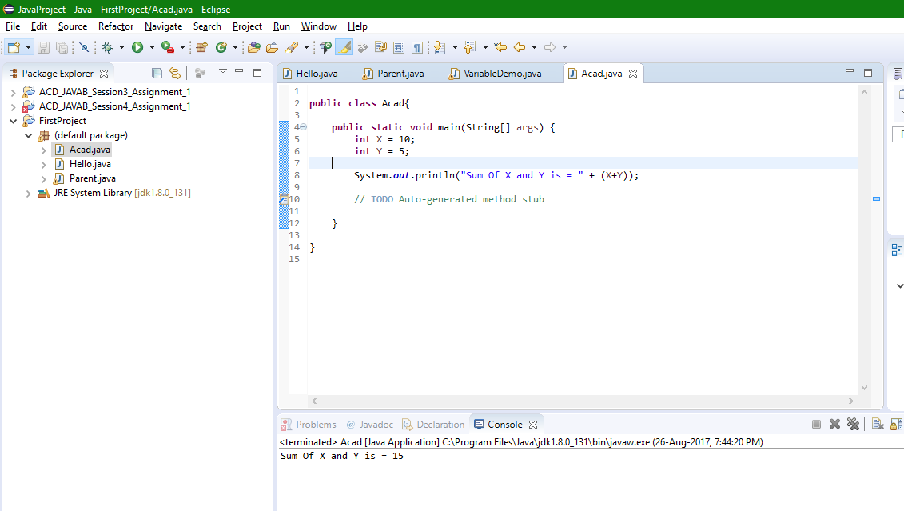

2) Rewrite the above code, where, inputs are provided by the user at runtime and the output is

printed.

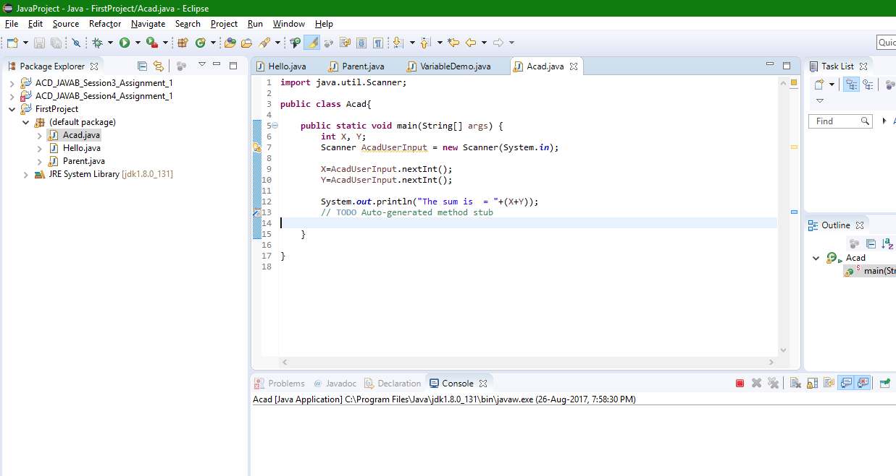

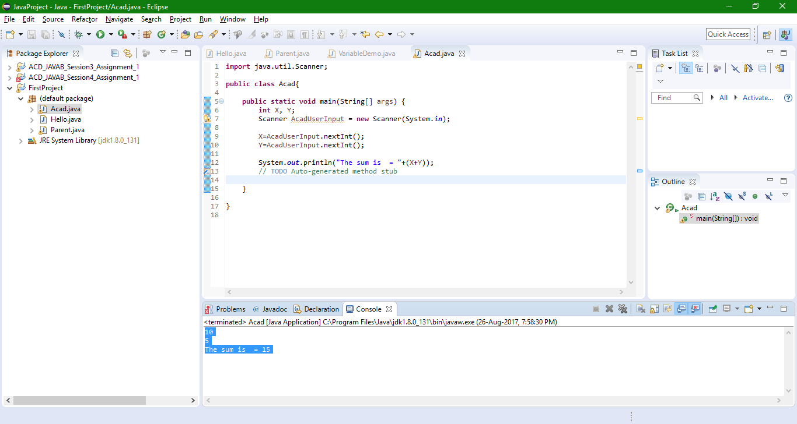

3) Write a program with method name sum() that accepts two parameters from user and print

the sum of two numbers. Output format should be as:

First Number is:

Second number is:

Sum is:

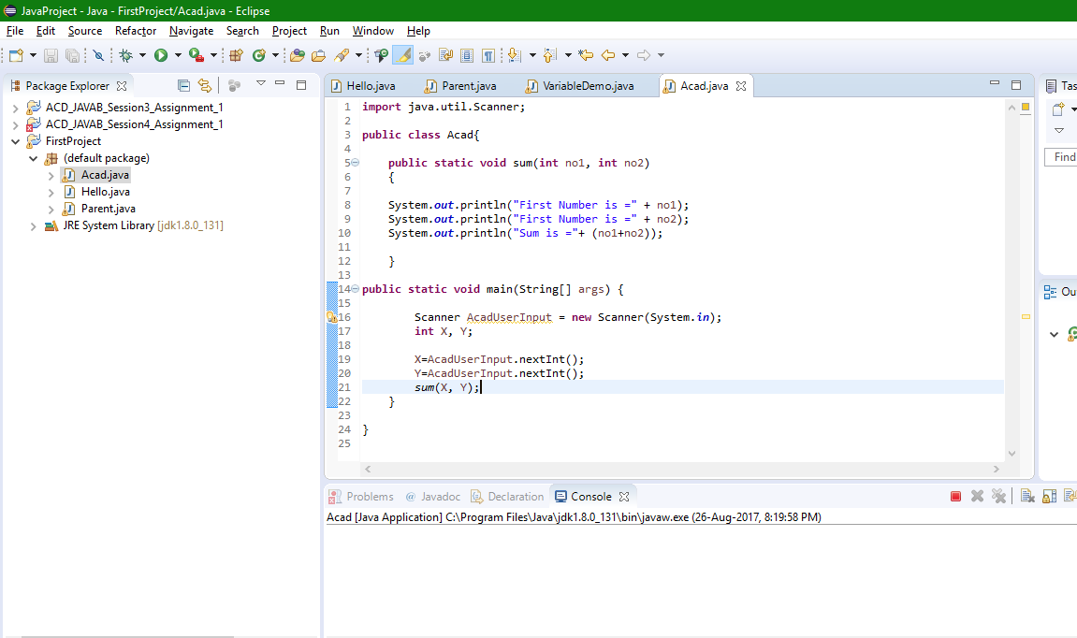

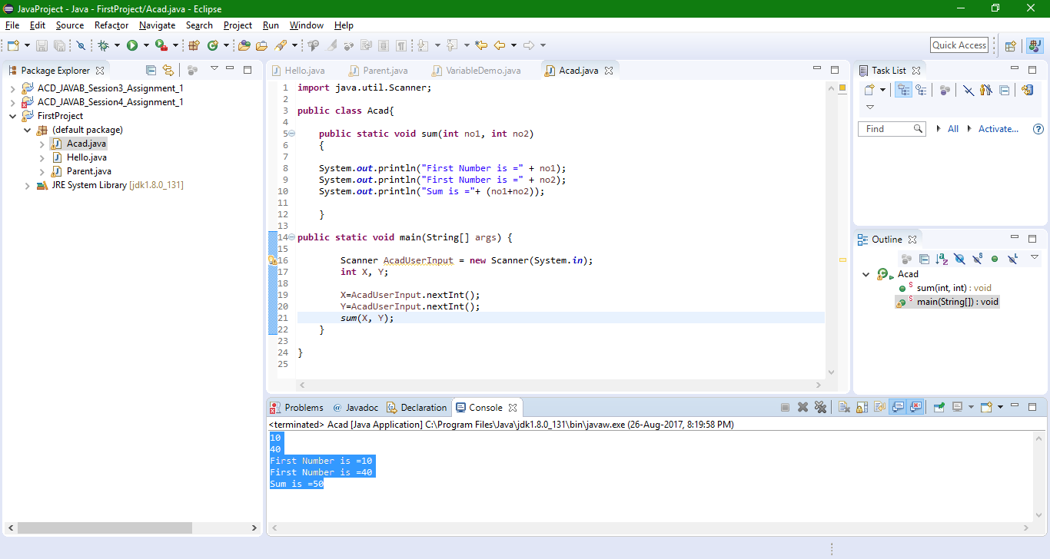

4) Write a program to accepts two numbers from stdin and find all the odd as well as even

numbers present in between them.

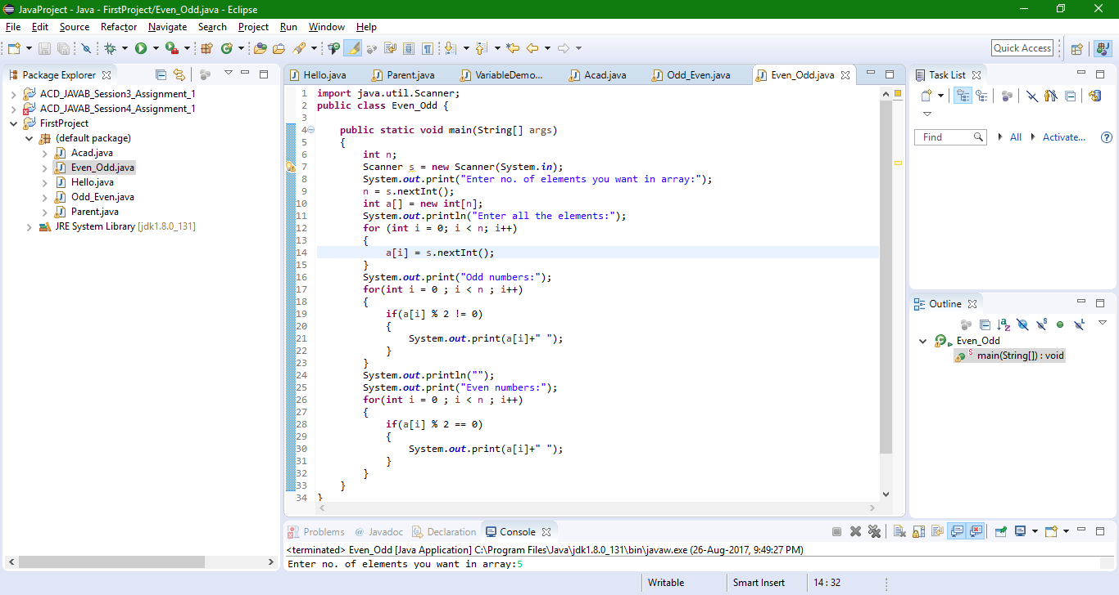

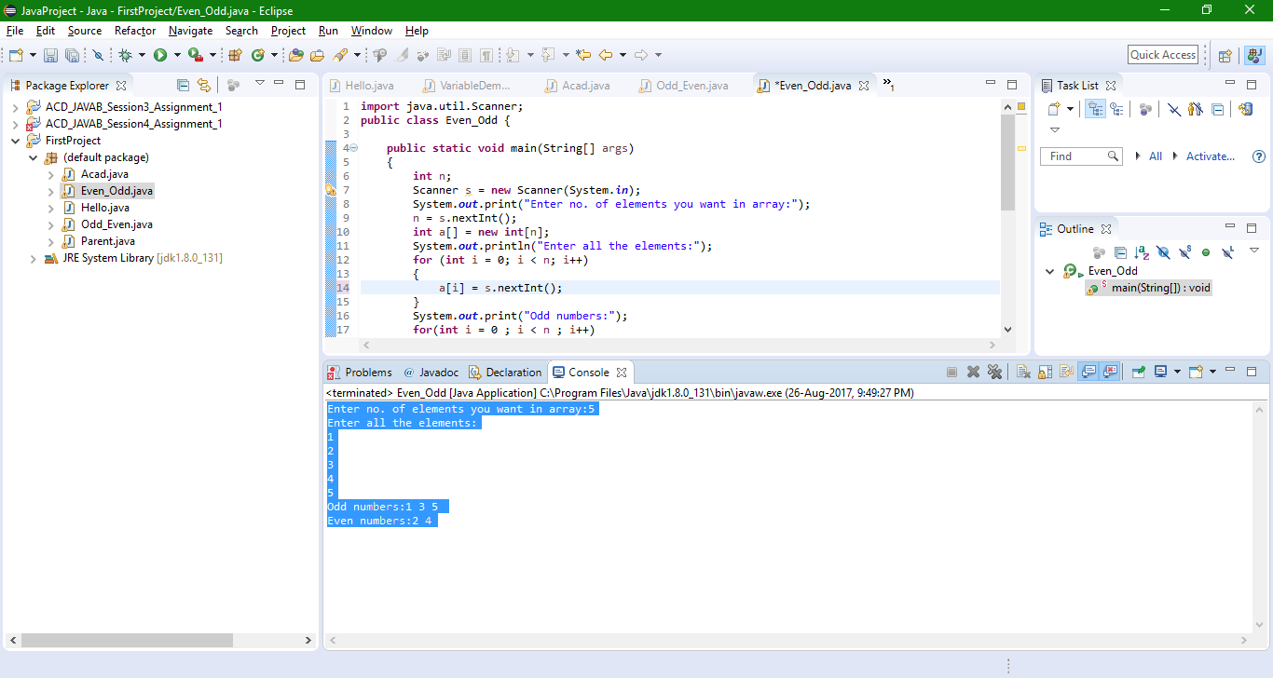

5) The task was to find the “first 10 multiples” of the

number entered from stdin:

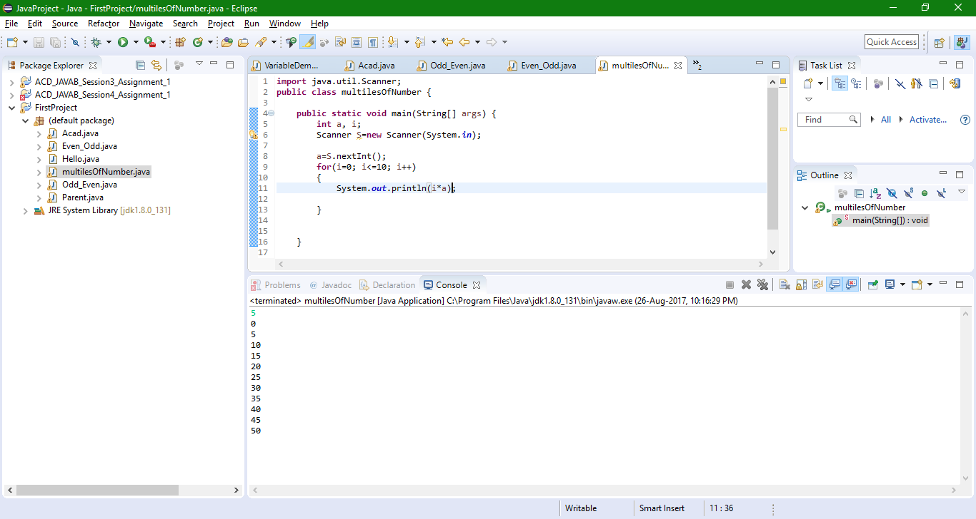

6) Write a program consisting method sum() and demonstrate the concept of method

overloading using this method.

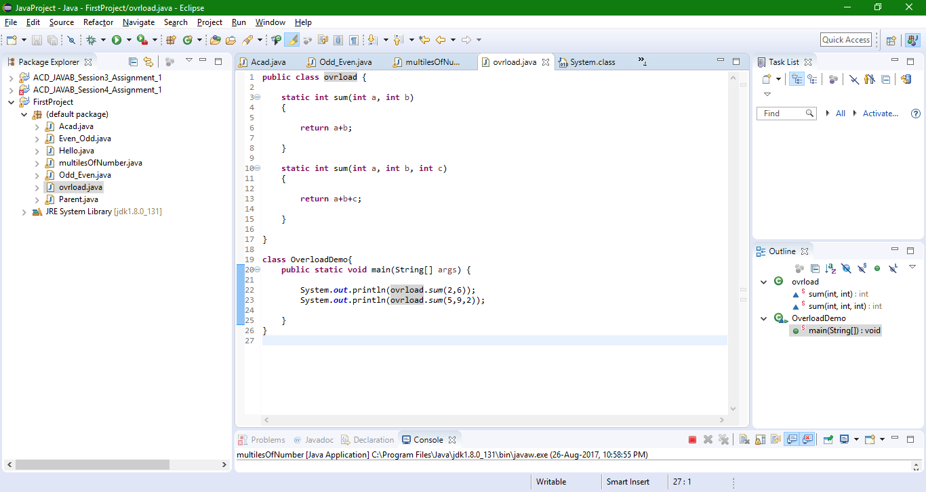

7) Can you overload a method with same return type.? Explain your answer with proper logic.

verloaded based on the data type of arguments not on Method Return type

Ex:

float mymethod(int a, float b)

float mymethod(float var1, int var2)

Result: Perfectly fine. Valid case for overloading. Sequence of the data types are different, first method is having (int, float) and second is having (float, int).